How do cells work together in the human body?

**Key Concepts**

* All cells begin alike and differentiate into specialized cells.
* Specialized cells have different structures that allow them to perform unique functions.
* Groups of cells working together form tissues.
* Groups of tissues working together form organs, which work together in systems.

Life comes in an enormous range of sizes. It can be as small as a bacterium, which is invisible to the unaided eye. Or it can be large enough to fit half a dozen humans in its jaws alone, such as the school-bus-sized, prehistoric Megalodon shark. Scientists can only observe Megalodon through the fossils it left behind. Due to its huge size, however, it was made up of hundreds of trillions of cells.

A single-celled organism relies on the organelles within its one cell to carry out its life functions. A multi-celled organism requires a greater degree of organization to survive. Most of the cells in a multi-celled organism have different structures and abilities that help them carry out specific functions. But even these specialized cells are limited in what they can do on their own. As a result, the survival of a multi-celled organism relies on teamwork. Working together, specialized cells carry out life functions, such as digestion, breathing, and circulation. Such organization is key to developing complex life forms such as Megalodon and you.

**Cell specialization** refers to the fact that different types of cells have different structures and abilities to perform their functions efficiently. All cells start their lives as identical cells called stem cells. Each stem cell has the potential to become a specialized cell, such as a muscle cell or nerve cell, as it matures. During this process, the cell becomes altered to suit its specific functions. The series of events through which stem cells develop into specialized cells is called **cell differentiation**.

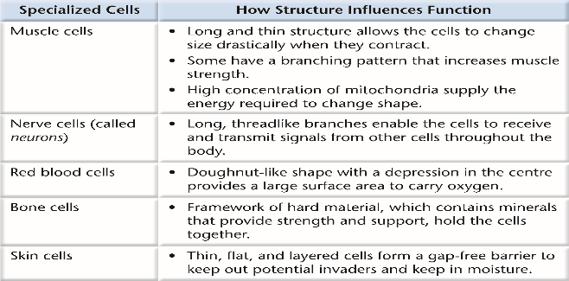Specialized cells have different structures that allow them to perform unique functions

Groups of cells working together form tissues

**C**ells are the basic unit of life. But even specialized cells can only accomplish so much on their own. This is where teamwork becomes important, as you discovered in the topic opener. When specialized cells work together to perform a specific function, they are known as a **tissue**. There are four basic types of tissues: muscle, epithelial, connective, and nervous tissue. Many different tissues may be classified into these four groups.

Groups of tissues working together form organs, which work together in systems.

Different tissues perform unique, individual functions. However, like specialized cells, they can only do so much on their own. Tissues working together overcome this limitation to form organs. An organ is made up of different tissues working together to perform a specific task. An organ contains at least two different types of tissues. For example, your heart is an organ. Within your heart, muscle tissue contracts and relaxes to pump blood through valves made of connective tissue. Th e heart also contains nerve tissue and a protective layer of epithelial tissue. Figure 1.16 shows some of the other organs found in your body along with their functions.

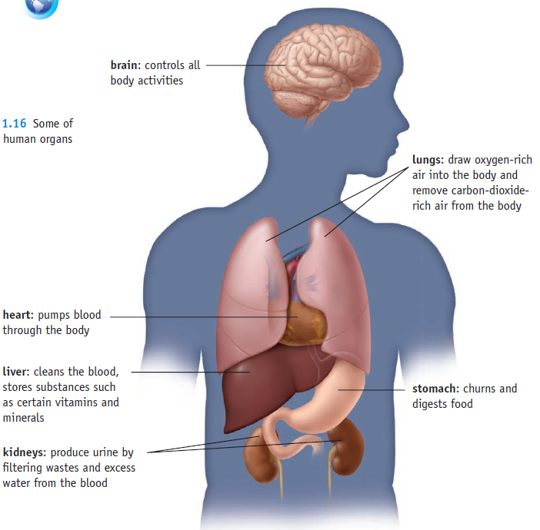

**Organs Working Together Form Systems**

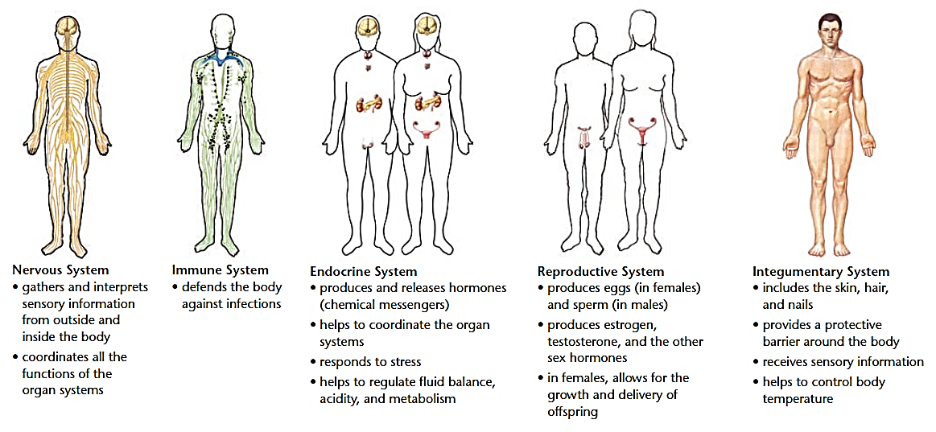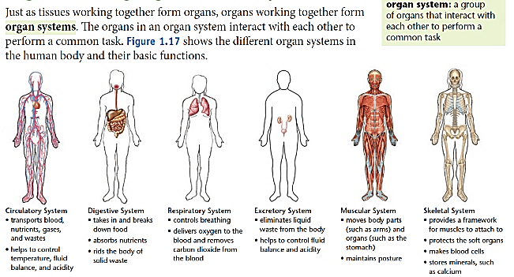Just as tissues working together form organs, organs working together form **organ systems**. Th e organs in an organ system interact with each other to perform a common task. **Figure 1.17** shows the different organ systems in the human body and their basic functions.

A Well-Oiled Machine

All of the organs and organ systems of the human body work together like a well-oiled machine. This is because they are closely regulated by the nervous and endocrine systems. The nervous system controls virtually all body activities, and the endocrine system secretes hormones that regulate these activities. Functioning together, the organ systems supply body cells with all the substances they need and eliminate their wastes. They also keep temperature, pH, and other conditions at just the right levels to support life processes.

Maintaining Homeostasis

The process in which organ systems work to maintain a stable internal environment is called homeostasis. Keeping a stable internal environment requires constant adjustments. Here are just three of the many ways that human organ systems help the body maintain homeostasis:

• Respiratory system: A high concentration of carbon dioxide in the blood triggers faster breathing. The lungs exhale more frequently, which removes carbon dioxide from the body more quickly.

• Excretory system: A low level of water in the blood triggers retention of water by the kidneys. The kidneys produce more concentrated urine, so less water is lost from the body.

• Endocrine system: A high concentration of sugar in the blood triggers secretion of insulin by an endocrine gland called the pancreas. Insulin is a hormone that helps cells absorb sugar from the blood.

Review the main concepts

**1.** Draw a flowchart that shows the following terms in order of their complexity, from least complex to most complex: organs, tissues, systems, cells, organism.

**2.** Which two systems in the body are the most dependent on each other? Choose two systems and explain how they rely on each other to do their job within the body?

**3.** Create an analogy or a simile to help a younger student understand a body system.

* An analogy is a short paragraph and is structured along the lines of:

The __________ system is like a/the _______________. They both… (2 to 4 sentences)

* A simile is very brief and only two sentences and identifies one key similarity. It has the structure:

The ______________ system is like a/the ________________. They both … (limit is one sentence here)